A

PROJECTREPORTON

**A Network for Monitoring and Assessing Water Quality for Drinking And Irrigation Purpose**

Submitted in partial fulfillment of the requirements fortheawardofthedegree of

## MASTEROFCOMPUTERAPPLICATIONS

By

MAMATHA DIGUMARTHI

22P11F00A8

Undertheesteemed guidanceof

Ms. NALINI

MCA Assistant Professor



## DEPARTMENT OF COMPUTER APPLICATIONSCHADALAWADARAMANAMMAENGINEERINGCOLLEGE

**(AUTONOMOUS)**

## Accredited by NAAC , Approved by A.I.C.T.E,NewDelhi,AffiliatedtoJNTUA,Anantapuramu,

## CHADALAWADANAGAR, RENIGUNTA ROAD, TIRUPATI-517506

## CHITTOOR(Dist.),A.P,INDIA

## 2023-2024

***

## CHADALAWADARAMANAMMAENGINEERINGCOLLEGE

**(AUTONOMOUS)**

**DEPARTMENTOFCOMPUTERAPPLICATIONS**

**2023-2024**



**CERTIFICATE**

This is to certify that the project work entitled "A Network for Monitoring And Assessing Water Quality for Drinking And Irrigation Purpose**”**isabonafideworkdoneby**MAMATHA DIGUMARTHI(22P11F00A8),**intheDepartmentof"MASTEROFCOMPUTERAPPLICATIONS",andis submittedto ChadalawadaRamanammaEngineeringCollege(Autonomous),Tirupati in partial fulfillment of the requirements for the award of the degree of Master of Computer Applications andtheprojectwork iscarriedoutundermyguidanceduringtheacademicyear2023-2024.

**PROJECTGUIDE HEADOFTHEDEPARTMENT**

**Ms. NALINI Dr.K.Sekar**

**MCA Assistant ProfessorProfessor& Head**

Submittedfortheproject viva-voceexamination heldon

INTERNALEXAMINER EXTERNALEXAMINER

# ACKNOWLEDGEMENT

Iamthankfultomyguide**Ms. Nalini,MCA Assistant Professor** for his valuable guidance and encouragement. His helping attitude and suggestions have helped me in the successful completion of theproject.

I hereby wishtoexpressmydeepsenseofgratitudeto**Dr.K.SEKAR**, Head,DepartmentofComputerApplicationsforallprovisionsmadeandforhisconstantencouragementthroughout the work.

I express my sincere thanks to our beloved principal Dr.P.RAMESH KUMARforprovidingallthefacilitiesandsupportincompletingmyprojectreportsuccessfully.

I sincerely thank our ChairmanDr. CHADALAWADA KRISHNA MURTHY forprovidingnecessaryinfrastructureandresourcesatChadalawadaRamanammaEngineeringCollege(Autonomous), Tirupati.

Successfulcompletionofanyprojectcannotbedonewithoutpropersupportandencouragement.MysincerethankstotheManagementforprovidingallthenecessaryfacilitiesduring the Courseof my study.

Iwouldliketothankmyparentsandfriends,whohavethegreatestcontributionsinallmyachievements, forthegreatcareandblessings inmakingmesuccessfulinallmyendeavors.

Iwouldliketo expressmydeepgratitudetoallthosewhohelpedme directlyorindirectlytotransform an ideainto my working project.

**Mamatha Digumarthi**

**22P11FOOA8**

# CONTENTS

|  |  |  |
| --- | --- | --- |
| **S.NO** | **DESCRIPTION** | **PAGENO** |
| **1** | **INTRODUCTION** | 01-02 |
| **2** | **LITERATURESURVEY**   * 1. DIFFERENTAUTHORSDISCUSSION   2. DOMAINDESCRIPTION | 03-05 |
| **3** | **EXISTINGSYSTEM**   * 1. EXISTINGSYSTEM   2. DRAWBACKSOFEXISTINGSYSTEM | 06-07 |
| **4** | **PROPOSEDSYSTEM**   * 1. PROPOSEDSYSTEM   2. ADVANTAGESINPROPOSEDSYSTEM   3. PROBLEMDEFINITION | 8-9 |
| **5** | **MODULESDESCRIPTION**   * 1. MODULESEXPLANATION | 10-13 |
| **6** | **PROJECTDESIGN**   * 1. SYSTEMARCHITECTURE   2. UMLDIAGRAMS   3. PROJECTREQUIREMENTS | 14-24 |
| **7** | **PROJECTIMPLEMENTATION**   * 1. TECHNOLOGIESUSED   2. SOURCECODE   3. SYSTEMTESTING | 25-42 |
| **8** | **SCREENSHOTS** | 43-61 |
| **9** | **CONCLUSION** | 62 |
| **10** | **REFERENCES** | 63-65 |

|  |  |  |  |
| --- | --- | --- | --- |
| LIST OF FIGURES | | | |
| S.No | Figure Number | Name of the Figure | Page Number |
| 1 | 6.1 | System Architecture | 14 |
| 2 | 6.2.1 | Usecase Diagram | 15 |
| 3 | 6.2.2 | Sequence Diagram | 16 |
| 4 | 6.2.3 | Collaborative Diagram | 17 |
| 5 | 6.2.4 | Class Diagram | 18 |
| 6 | 6.2.5 | Activity Diagram | 19 |
| 7 | 7.1 | Operator in Python | 30 |
| 8 | 8.1.1 | Compilation of data visualization | 43 |
| 9 | 8.1.2 | Line graph Diagram | 44-45 |
| 10 | 8.1.3 | Data flow Diagram | 46 |
| 11 | 8.1.4 | Linear regression | 47 |
| 12 | 8.1.5 | Portability graph | 48 |
| 13 | 8.1.6 | Diameter narrowing | 49 |
| 14 | 8.1.7 | Algorithm | 50 |
| 15 | 8.1.8 | Box plot | 51 |
| 16 | 8.1.9 | Water Level | 52-58 |
| 17 | 8.1.10 | Crop yield | 59 |
| 18 | 8.1.11 | PH value | 60 |
| 19 | 8.1.12 | Water quality prediction | 61 |

**ABSTRACT**

Access to clean and safe water is fundamental for human health and agricultural sustainability. This study pre

sents the design and implementation of a comprehensive network aimed at monitoring and assessing water quality for both drinking and irrigation purposes. The network integrates sensor technologies, data analytics, and real-time monitoring systems to ensure continuous surveillance and evaluation of water quality parameters.

The primary focus of this network is twofold: ensuring the portability of drinking water sources and optimizing water quality for agricultural irrigation. Utilizing a distributed sensor network deployed across critical water sources and agricultural fields, this system collects real-time data on various parameters such as pH levels, dissolved oxygen, turbidity, salinity, and the presence of contaminants.The collected data is processed and analyzed using advanced data analytics techniques to identify trends, anomalies, and potential risks to water quality. Machine learning algorithms are employed to develop predictive models for early detection of water quality deterioration and contamination events.Moreover, this network facilitates proactive decision-making by providing actionable insights to water management authorities, farmers, and stakeholders. It aims to improve resource allocation, guide irrigation practices, and implement timely interventions to maintain optimal water quality for both human consumption and agricultural productivity.The implementation of such a network holds significant potential in ensuring water security, reducing health risks associated with contaminated water, and promoting sustainable agricultural practices. The findings and methodologies presented in this study offer valuable insights into the development of robust and scalable networks for continual water quality monitoring and management.

# 1.INTRODUCTION

Access to clean and safe water is a cornerstone of human health and agricultural sustainability. However, ensuring the consistent quality of water sources for both drinking and irrigation purposes remains a significant challenge worldwide. The integration of advanced technologies and systematic monitoring approaches has become imperative to address this challenge effectively.

This project introduces a comprehensive network designed for the continuous monitoring and assessment of water quality, targeting its suitability for human consumption and agricultural use. The network employs a combination of sensor technologies, data analytics, and real-time monitoring systems to facilitate proactive and informed decision-making regarding water safety and its impact on agricultural productivity.

At the heart of this endeavor lies the aim to address critical concerns related to water quality. For drinking purposes, the focus is on identifying contaminants, microbial hazards, and maintaining optimal chemical parameters. Simultaneously, for irrigation, the emphasis is on ensuring suitable nutrient levels, controlling salinity, and optimizing water resources for crop health and yield.

The proposed network encompasses a multifaceted approach, integrating a diverse array of sensors deployed across various water sources and agricultural fields. These sensors continuously collect data on crucial water quality parameters, encompassing pH levels, dissolved oxygen content, turbidity, salinity, nutrient concentrations, and the presence of contaminants or pollutants.

Furthermore, the collected data undergoes rigorous analysis leveraging advanced data analytics techniques, such as machine learning algorithms, statistical models, and time-series analysis. These analyses are pivotal in detecting anomalies, predicting trends, and providing early warnings regarding potential water quality risks, enabling timely interventions to safeguard human health and agricultural sustainability.

The significance of this project extends beyond technological innovation. It embodies a proactive step towards ensuring water security, preserving environmental resources, and fostering resilient communities. By providing stakeholders with real-time insights and actionable information, the network empowers decision-makers, water management authorities, farmers, and local communities to adopt informed strategies for water resource management.

The subsequent sections delve into the architectural framework, methodologies, and functionalities of this network. Through the integration of cutting-edge technologies and comprehensive monitoring protocols, this initiative endeavors to revolutionize water quality assessment, playing a pivotal role in shaping asustainable and healthier future.

# 2.LITERATURESURVEY

Machine learning-based marketing research has been actively conducted in the fields of customer segmentation, customer churn prediction, and personalized recommendation. With the emergence of online digital marketing, related research is increasing further due to the real-time nature of online and the ease of accessing data.

**2.1.Title:**A Network for monitoring and assessing water quality for drinking and irrigation purposes.

**Authors:** [Olasupo O. Ajayi](https://ieeexplore.ieee.org/author/37086172770)

Department of Computer Science, University of the Western Cape, Cape Town, Bellville, South Africa

Olasupo O. Ajayi received the Ph.D. degree in computer science from the University of Lagos, in 2017. He is currently a Senior Lecturer with the Department of Computer Science, University of the Western Cape, Cape Town, South Africa (UWC). He has published a number of articles around these research interests in journals, books, and proceedings of international conferences. His research interests include cloud/fog/edge computing, the Internet of Things, cyber-physical systems, and the enabling technologies of the 4IR.

[Zaheed Gaffoor](https://ieeexplore.ieee.org/author/37089378421)

Department of Earth Science, University of the Western Cape, Cape Town, Bellville, South Africa

Zaheed Gaffoor is currently pursuing the Ph.D. degree with the Department of Earth Science, UWC. He is also a Research Scientist with IBM Research, where he works on climate and weather related research. His research interests include the application of data driven tools and techniques in the hydrological domain.

**Description:**On a network for monitoring and assessing water quality for drinking and irrigation purposes focuses on the integration of advanced technologies such as IOT, wireless sensor networks, and data analytics to ensure real-time and accurate monitoring of water parameters. This approach aims to address the challenges of water pollution and scarcity by providing continuous surveillance and early warning systems for contaminants. The survey highlights various studies that have successfully implemented these technologies to monitor parameters like pH, turbidity, temperature, and chemical contaminants, ensuring that the water meets safety standards for human consumption and agricultural use. The effectiveness of these networks in improving water management, reducing health risks, and enhancing agricultural productivity is emphasized, alongside the need for further research in optimizing sensor deployment, data accuracy, and system scalability.

## 2.2DOMAINDESCRIPTION

The water monitoring network proposed in this work is to be deployed in the City of Cape Town in Western Cape, South Africa, with the intention of monitoring water parameters in water storage dams and/or water treatment plants across the city. Data gathered by the monitoring network are then passed through Machine Learning (ML) models to determine their suitability for consumption or irrigation purposes. The specific contributions of this work can be summarized as follows:

**Key aspects of this domain include:**

* The wireless Communication network for monitoring
* Assessing Water Probability
* Assessing Water Quality for Irrigation

# 3.EXISTINGSYSTEM

## 3.1 EXISTINGSYSTEM

* Water quality assessment often involves sporadic manual sampling of water from various sources, such as rivers, reservoirs, wells, and irrigation canals. These samples are then transported to laboratories for comprehensive analysis.
* Laboratory tests include measuring parameters like pH levels, dissolved oxygen content, turbidity, total dissolved solids (TDS), nitrates, phosphates, heavy metals, and microbial contamination. These tests are time-consuming and often provide delayed results.Water quality standards and guidelines, established by local, national, or international regulatory bodies (e.g., EPA in the United States or WHO guidelines), serve as benchmarks for acceptable levels of various contaminants and parameters in water for human consumption and agricultural use.
* Regulatory agencies periodically conduct assessments and enforce compliance with these standards, often based on historical data and intermittent sample analysis.

## 3.2DRAWBACKSOFEXISTINGSYSTEM

* + Establishing and maintaining a comprehensive sensor network coupled with IoT devices and real-time monitoring systems can be financially burdensome. The initial setup costs, as well as ongoing maintenance expenses, may pose challenges, particularly for regions with limited resources or infrastructure.
  + Collecting and transmitting sensitive water quality data in real time raises concerns about data security and privacy. Ensuring the encryption and protection of data from cyber threats or unauthorized access becomes crucial to maintain the integrity of the system and prevent potential breaches.
  + The reliability of sensor devices and IOT infrastructure over extended periods can be a concern. Technical issues, sensor failures, or calibration drifts may occur, requiring regular maintenance and monitoring to ensure accuracy and consistency in data collection.
  + Ensuring the accuracy and calibration of sensor readings is critical for reliable water quality assessment. Calibration drift or sensor inaccuracies could lead to erroneous data, affecting the quality of analysis and decision-making based on the collected information.
  + Despite advancements, establishing complete coverage across vast or remote geographical areas might be challenging. Some regions may lack adequate network connectivity or suitable infrastructure, limiting the accessibility and scope of the monitoring network.

# 4.PROPOSEDSYSTEM

## 4.1PROPOSED SYSTEM

Deployment of a network of sensors and IOT devices strategically positioned across water sources (e.g., rivers, reservoirs, wells) and agricultural fields. These sensors measure various parameters including pH levels, dissolved oxygen, turbidity, salinity, nutrient levels, pesticides, and microbial contaminants.Continuous and real-time data collection from sensors, utilizing telemetry and communication technologies.

This enables immediate access to water quality data, eliminating delays associated with traditional manual sampling and laboratory analysis.Utilization of advanced data analytics techniques, including machine learning algorithms, to process and analyze the collected data. Machine learning models are developed to predict water quality trends, identify anomalies, and forecast potential contamination events.

## 4.2 ADVANTAGESOFPROPOSED SYSTEM

* + Continuous monitoring through a network of sensors and IOT devices enables real-time data collection. Immediate alerts can be generated in response to deviations in water quality parameters, allowing for prompt interventions and mitigating potential risks to human health and agricultural productivity.
  + The network facilitates the early detection of contaminants, microbial hazards, or changes in water quality parameters. Identifying these issues at their onset helps in preventing the spread of waterborne diseases and ensures early remediation to maintain safe water sources.
  + With consistent monitoring and analysis, the network ensures the continuous assessment of water quality for both drinking and irrigation purposes. This leads to better water management practices, minimizing health risks associated with contaminated water and optimizing irrigation practices for crop health and yield.
  + Data-driven insights derived from the network aid in optimizing resource allocation and utilization. Authorities can prioritize resources based on identified areas with poor water quality, thereby efficiently targeting interventions and management strategies.

**4.3 PROBLEM DEFINITION**

* Water quality is a critical factor for both drinking water supplies and agricultural irrigation systems.
* Contaminants in water can pose significant health risks to humans and animals, damage crops, and degrade soil health.
* Ensuring the safety and suitability of water for these purposes requires continuous monitoring and timely assessment.

**5.MODULEDESCRIPTION**

## 5.1 MODULESEXPLAINATION

**1.Sensor Deployment and Data Acquisition:**

This module involves the deployment of various sensors across water sources (such as rivers, reservoirs, wells) and agricultural fields to measure water quality parameters. Sensors collect data on pH levels, dissolved oxygen, turbidity, salinity, nutrient content, and contaminants.

* + - Selection and installation of appropriate sensors.
    - Continuous data acquisition from distributed sensors.

**2. Data Transmission and Telemetry:**

This module focuses on transmitting data from sensors to a central data processing unit or cloud-based platform. It involves the use of telemetry and communication technologies to ensure real-time transmission of water quality data.

* + - Telemetry system setup for remote data transmission.
    - Ensuring data integrity during transmission.

**3. Data Storage and Management:**

This module manages the storage and organization of collected data. It involves creating databases or data repositories for storing historical and real-time water quality data.

* + - Database design for efficient storage and retrieval.
    - Data archiving and backup mechanisms.

**4. Data Processing and Analytics:**

This module processes and analyzes the collected data to derive meaningful insights. It involves applying data analytics techniques, including statistical analysis and machine learning algorithms, to identify patterns, anomalies, and trends in water quality parameters.

* + - Implementing algorithms for data analysis and anomaly detection.
    - Developing predictive models for early warning systems.

**5. Decision Support System and Visualization:**

This module focuses on creating a user-friendly interface to visualize and interpret water quality data. It aids in decision-making by presenting actionable insights derived from processed data to stakeholders.

**Algorithm:**

1. **Predictive Modeling for Water Quality:**
   * **Random Forest:**
     + Random Forest can predict water quality parameters based on historical data collected from sensors. It handles nonlinear relationships and works well with large datasets.
   * **Gradient Boosting:**
     + Gradient Boosting algorithms like XGBoost or LightGBM can also predict water quality trends and anomalies by sequentially improving the model's predictions.
2. **Anomaly Detection:**
   * **Isolation Forest:**
     + Isolation Forest can identify anomalies or sudden deviations in water quality parameters. It's effective for outlier detection and can work well with high-dimensional data.
   * **One-Class SVM:**
     + One-Class Support Vector Machines are used for detecting abnormal instances. It's particularly useful when dealing with datasets containing mostly normal instances and a few anomalies.
3. **Cluster Analysis for Pattern Identification:**
   * **K-means Clustering:**
     + *:* K-means can group similar water quality data points to identify patterns or clusters. It helps in understanding different water quality profiles across various sources.
4. **Time-Series Analysis:**
   * + ARIMA models can analyze temporal trends in water quality parameters, predicting future values based on past observations. This is useful for understanding seasonal variations or long-term trends.
5. **Deep Learning for Sensor Data:**
   * + **Recurrent Neural Networks (RNNs):**RNNs can process sequential sensor data, capturing dependencies between successive water quality measurements. They are suitable for analyzing time-series sensor data.

# 6. PROJECTDESIGN

**6.1 SYSTEM ARCHITECTURE**

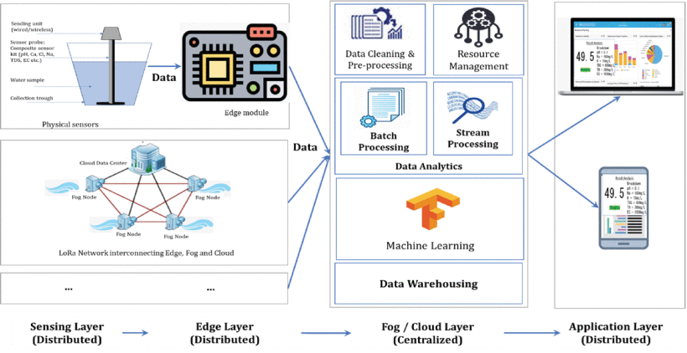

**Fig 6.1 System Architecture**

**6.2 UML DIAGRAM**

**6.2.1 USECASE DIAGRAM**

User

Sensor Node

Water Quality Database retrieves

Water Quality Database

User analyzes data and sets

Central Monitoring System

Configure for Irrigation

Irrigation Feedback

Sensor Node

**Fig 6.2.1 Use case diagram**

**6.2.2 FLOW CHART DIAGRAM**

Data Set

User

StopWord

Removal

Sensor Node

Stemming

Word Removal

Central

Monitoring

Positive Word

Removal

Water Quality

Negative Word

Removal

Processes data

Frequency

Store Data

Request Water Quality Data

Central Monitoring System

Water Quality Database

Water Quality Report

Request Historical Data

Result

**Fig 6.2.2 Sequence Diagram**

**6.2.3 Collaborative Diagram:**

User

Sensor Node

Central Monitoring

Water Quality

processes data

Store Data

1: Request Water Quality Data

2: Central Monitoring System

3: Water Quality Database

4: Water Quality Report

5: Request Historical Data

6: Result

**Fig 6.2.3 Collaborative Diagram**

**6.2.4. CLASS DIAGRAM:**

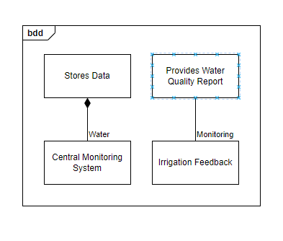

**Fig.6.2.4. CLASS DIAGRAM**

**6.2.5 Activity Diagram:**

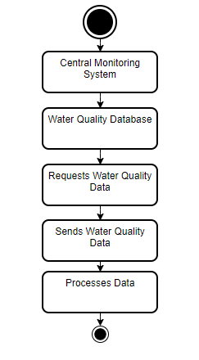

**Fig.6.2.5 Activity Diagram**

**6.3 PROJECT REQUIREMENTS**

### Functional Requirements:

1. **Data Collection:**
   * **Sensors:** Deploy sensors to measure parameters such as pH, turbidity, temperature, dissolved oxygen, nitrates, phosphates, and other relevant contaminants.
   * **Sampling Frequency:** Define how often data should be collected (e.g., every hour, daily).
   * **Geographical Coverage:** Ensure sensors are placed in key locations including water sources, treatment plants, and distribution points.
2. **Data Transmission:**
   * **Connectivity:** Utilize appropriate communication technologies (e.g., IoT, GSM, satellite) to transmit data from sensors to central databases.
   * **Data Integrity:** Ensure secure and reliable data transmission to prevent data loss or tampering.
3. **Data Storage:**
   * **Database Management:** Implement a scalable and secure database to store collected data.
   * **Data Retention:** Define data retention policies, specifying how long data should be kept for historical analysis.
4. **Data Analysis:**
   * **Real-time Processing:** Analyze data in real-time to detect anomalies and trigger alerts.
   * **Historical Analysis:** Perform trend analysis and generate reports on water quality over time.
5. **Reporting and Alerts:**
   * **Dashboards:** Develop user-friendly dashboards for stakeholders to monitor water quality status.
   * **Alerts:** Set up automated alerts via SMS, email, or app notifications for any detected water quality issues.
6. **User Access:**
   * **Role-based Access Control:** Ensure different access levels for various users (e.g., administrators, analysts, public).
   * **Mobile Access:** Provide mobile-friendly interfaces for on-the-go monitoring.
7. **Integration:**
   * **Interoperability:** Ensure the system can integrate with existing water management systems and public health databases.
   * **APIs:** Provide APIs for data sharing and integration with third-party applications.

| **Req#** | **Requirement** | **Comments** | **Priority** | **Date Rvwd** | **SME Reviewed / Approved** |
| --- | --- | --- | --- | --- | --- |
| BR_LR_05 | The system should associate a supervisor indicator with each job class. | Business Process = “Maintenance | 3 | 7/13/04 | Bob Dylan, Mick Jagger |
| BR_LR_08 | The system should handle any number of fees (existing and new) associated with unions. | Business Process = “Changing Dues in the System”  An example of a new fee is an initiation fee. | 2 | 7/13/04 | Bob Dylan, Mick Jagger |
| BR_LR_10 | The system should capture and maintain job class status (i.e., active or inactive) | Business Process = “Maintenance”  Some job classes are old and are no longer used. However, they still need to be maintained for legal, contract and historical purposes. | 2 | 7/13/04 | Bob Dylan, Mick Jagger |
| BR_LR_16 | The system should assign the Supervisor Code based on the value in the Job Class table and additional criteria as specified by the clients. | April 2005 – New requirement. It is one of three new requirements from BR_LR_03. | 2 |  |  |
| BR_LR_18 | The system should provide the Labor Relations office with the ability to override the system-derived Bargaining Unit code and the Union Code for to-be-determined employee types, including hourly appointments. | April 2005 – New requirement. It is one of three new requirements from BR_LR_04.  5/11/2005 – Priority changed from 2 to 3. | 2  3 |  |  |

### Non-Functional Requirements:

1. **Performance:**
   * **Scalability:** The system should be able to handle increasing amounts of data as more sensors are added.
   * **Latency:** Ensure low latency in data transmission and processing for real-time monitoring.
2. **Reliability:**
   * **Uptime:** Aim for high system uptime (e.g., 99.9% availability).
   * **Fault Tolerance:** Implement redundancy and failover mechanisms to maintain functionality during failures.
3. **Security:**
   * **Data Encryption:** Ensure data is encrypted during transmission and storage.
   * **Access Control:** Implement strong authentication and authorization measures.
   * **Audit Trails:** Maintain logs of all system activities for security audits.
4. **Usability:**
   * **User Interface:** Design intuitive interfaces for different user roles.
   * **Training:** Provide training resources and support for users.
5. **Maintainability:**
   * **Modularity:** Design the system with modular components for easier updates and maintenance.
   * **Documentation:** Maintain comprehensive documentation for system architecture, APIs, and user guides.
6. **Compliance:**
   * **Regulatory Standards:** Ensure the system complies with relevant local and international water quality monitoring standards and regulations.
   * **Data Privacy:** Adhere to data privacy laws and regulations, protecting personal data of users.
7. **Cost-effectiveness:**
   * **Operational Costs:** Optimize the system to minimize operational costs while maintaining performance.
   * **Scalability:** Design the system to scale efficiently without incurring excessive costs.

# 7. PROJECTIMPLEMENTATION

**MINIMUM HARDWARE REQUIREMENTS:**

* System : Pentium IV 2.4 GHz.
* Hard Disk : 40 GB.
* Monitor : 15 inch VGA Color.
* Mouse : Logitech Mouse.
* Ram : 512 MB
* Keyboard : Standard Keyboard

**MINIMUM SOFTWARE REQUIREMENTS:**

* Operating System : Windows XP.
* Platform : PYTHON TECHNOLOGY
* Tool : Python 3.6
* Front End : Python anaconda script

**7.1 TECHNOLOGIES USED**

**Introduction of python**

**1. Easy to learn:** Python has a simple syntax and is relatively easy to learn, even for those without prior programming experience.

**2. Fast development:** Python's syntax and nature allow for rapid development and prototyping.

**3. Large community:** Python has a vast and active community, ensuring there are plenty of resources available.

**4. Data analysis:** Python is ideal for data analysis, with popular libraries like Pandas, NumPy, and Matplotlib.

**5. Machine learning:** Python is a popular choice for machine learning, with libraries like scikit-learn, TensorFlow, and PyTorch.

**6. Web development:** Python can be used for web development, with frameworks like Django, Flask, and Pyramid.

**Python Libraries for Coupon Issuance**

**1. Pandas:** For data manipulation and analysis.

**2. NumPy:** For numerical computations.

**3. Matplotlib:** For data visualization.

**4. Scikit-learn:** For machine learning and customer segmentation.

**5. Flask or Django:** For building the web application.

**6. Python-requests:** For API integrations.

**What is a Client Server:**

**Client:**

* The client is the user-facing application that customers interact with to receive and redeem digital coupons.
* This can be a mobile app, web application, or even an in-mall kiosk.
* The client sends requests to the server for coupon issuance, redemption, and other operations.

**Server:**

* The server is the backend system that processes requests from the client and manages the coupon issuance and redemption process.
* It hosts the database, business logic, and API integrations.
* The server generates and issues coupons, tracks redemptions, and updates customer profiles.

#### FeaturesofTheLanguageUsed

Inmyproject,Ihavechosenpythonlanguagefordeveloping thecode.

#### AboutPython

#### Python was developed by “Guido van Rossum” in the late eighties and early nineties at the National Research Institute for Mathematics and Computer Science in the Netherlands.

#### Python is derived from many other languages, including ABC, Modula-3, C, C++, Algol-68, SmallTalk, and Unix shell and other scripting languages.

#### Python is copyrighted. Like Perl, Python source code is now available under the GNU General Public License (GPL).

#### Python is now maintained by a core development team at the institute, although Guido van Rossum still holds a vital role in directing its progress.

#### Python Features:

#### Python's features include:

#### Easy-to-learn: Python has few keywords, simple structure, and a clearly defined syntax. This allows the student to pick up the language quickly.

#### Easy-to-read: Python code is more clearly defined and visible to the eyes.

#### Easy-to-maintain: Python's source code is fairly easy-to-maintain.

#### A broad standard library: Python's bulk of the library is very portable and cross-platform compatible on UNIX, Windows, and Macintosh.

#### Interactive Mode: Python has support for an interactive mode which allows interactive testing and debugging of snippets of code.

#### Portable: Python can run on a wide variety of hardware platforms and has the same interface on all platforms.

#### Extendable: You can add low-level modules to the Python interpreter. These modules enable programmers to add to or customize their tools to be more efficient.

#### Databases: Python provides interfaces to all major commercial databases.

#### GUI Programming: Python supports GUI applications that can be created and ported to many system calls, libraries and windows systems, such as Windows MFC, Macintosh, and the X Window system of Unix.

#### Scalable: Python provides a better structure and support for large programs than shell scripting.

#### Python has a big list of good features:

#### It supports functional and structured programming methods as well as OOP.

#### It can be used as a scripting language or can be compiled to byte-code for building large applications.

#### It provides very high-level dynamic data types and supports dynamic type checking.

#### IT supports automatic garbage collection.

#### It can be easily integrated with C, C++, COM, ActiveX, CORBA, and Java.

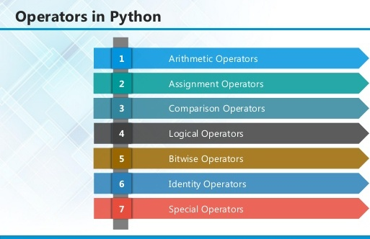

#### Fig 7.1 Operators in python

## 7.2 SOURCE CODE:

**from keras.models import Sequential**

**from keras.layers import Dense**

**from keras.layers import LSTM**

**from keras.layers import Dropout**

**import numpy as np**

**import tensorflow as tf**

**from tensorflow import keras**

**from tensorflow.keras import layers**

**import seaborn as sns**

**import pandas as pd**

**import matplotlib.pyplot as plt**

**from sklearn.utils import resample**

**from sklearn.utils import shuffle**

**import sklearn**

**from sklearn.preprocessing import MinMaxScaler**

**dataset_train = pd.read_csv('rawdata.csv')**

**dataset_train.isnull().sum().sum()**

**dataset_train.head(5)**

**df = dataset_train.mask(dataset_train==0).fillna(dataset_train.mean())**

**df.to_csv('cleandata.csv', index=False)**

**print("",df.info())**

**training_set =df.iloc[:, 1:3].values**

**print("",training_set)**

**df_col = df.columns.tolist()**

**print("",df_col)**

**plt.figure(figsize=(15, 6))**

**df['PH'].plot();**

**df['NO3'].plot();**

**df['Temp'].plot();**

**df['Rain'].plot();**

**#Analysing relationship between different features**

**cor_cols = df_col**

**plt.matshow(df.corr())**

**plt.xticks(range(len(cor_cols)), cor_cols)**

**plt.yticks(range(len(cor_cols)), cor_cols)**

**plt.colorbar()**

**plt.show()**

**sc = MinMaxScaler(feature_range =(0,1))**

**training_set_scaled =sc.fit_transform(training_set)**

**print("",training_set_scaled)**

**#Creating a window for previous data**

**def to_supervised(train):**

**window_size = 4**

**X = []**

**Y = []**

**for i in range(window_size, len(train)):**

**X.append(train[i-window_size:i,:])**

**Y.append(train[i,0:1])**

**return X,Y**

**X, Y = to_supervised(training_set_scaled)**

**X = np.array(X)**

**Y = np.array(Y)**

**print('Y' ,Y.shape)**

**print('X' ,X.shape)**

**model = Sequential()**

**model.add(LSTM(64, activation='relu', input_shape=(X.shape[1], X.shape[2]), return_sequences=True))**

**model.add(LSTM(32, activation='relu', return_sequences=True))**

**model.add(LSTM(32, activation='relu', return_sequences=False))**

**model.add(Dropout(0.2))**

**model.add(Dense(Y.shape[1]))**

**model.compile(optimizer='adam', loss='mse')**

**model.summary()**

**history = model.fit(X, Y, epochs=500, batch_size=30, validation_split=0.1, verbose=1)**

**model.save('WaterQulity.h5')**

**result = model.predict(X)**

**print("",result)**

**plt.plot(history.history['loss'])**

**plt.show()**

**plt.plot(history.history['loss'], label='Training loss')**

**#Splitting the dataset**

**n_train = 24*365**

**X_train, X_test = X[n_train:,] , X[:n_train,]**

**print('X_train' ,X_train.shape)**

**print('X_test' ,X_test.shape)**

**Y_train, Y_test = Y[n_train:,] , Y[:n_train,]**

**print('Y_train' ,Y_train.shape)**

**print('Y_test' ,Y_test.shape)**

**Y_pred = model.predict(X_test)**

**print('y_predicted',Y_pred.shape)**

**#print('X_train' ,X_train.shape)**

**print('X_test' ,X_test.shape)**

**print('scaled Values shape', training_set_scaled.shape)**

**d = training_set_scaled[:217,:]**

**print('dummy',d.shape)**

**print('Y_pred',Y_pred.shape)**

**Y_predicted = np.concatenate((Y_pred,d[:2107,1:]), axis =1)**

**print('concat y_pred',Y_pred.shape)**

**Y_tested = np.concatenate((Y_test, d[:217,1:]), axis = 1)**

**print('concatY_test', Y_test.shape)**

**plt.plot(history.history['val_loss'], label='Validation loss')**

**plt.legend()**

**#Splitting the dataset**

**n_train = 24*365**

**X_train, X_test = X[n_train:,] , X[:n_train,]**

**print('X_train' ,X_train.shape)**

**print('X_test' ,X_test.shape)**

**Y_train, Y_test = Y[n_train:,] , Y[:n_train,]**

**print('Y_train' ,Y_train.shape)**

**print('Y_test' ,Y_test.shape)**

**Y_pred = model.predict(X_test)**

**print('y_predicted',Y_pred.shape)**

**#print('X_train' ,X_train.shape)**

**print('X_test' ,X_test.shape)**

**print('scaled Values shape', training_set_scaled.shape)**

**d = training_set_scaled[:217,:]**

**print('dummy',d.shape)**

**print('Y_pred',Y_pred.shape)**

**Y_predicted = np.concatenate((Y_pred,d[:2107,1:]), axis =1)**

**print('concat y_pred',Y_pred.shape)**

**Y_tested = np.concatenate((Y_test, d[:217,1:]), axis = 1)**

**print('concatY_test', Y_test.shape)**

**Y_predicted = sc.inverse_transform(Y_predicted)**

**Y_tested = sc.inverse_transform(Y_tested)**

**Y_predicted = Y_predicted[:,0:1]**

**Y_tested = Y_tested[:,0:1]**

**print('Y_tested', Y_tested.shape)**

**print('Y_predicted', Y_predicted.shape)**

**plt.figure(figsize=(10,4))**

**plt.plot(Y_predicted[:100,:], color= 'blue',label = 'Predicted PH')**

**plt.plot(Y_tested[:100,:] , color = 'red',label = 'Actual PH')**

**plt.title("PH value prediction")**

**plt.xlabel("Date")**

**plt.ylabel("Qulity level")**

**plt.legend()**

**plt.show()**

**plt.savefig('graph.png')**

**7.3.SYSTEM TESTING**

The purpose of testing is to discover errors. Testing is the process of trying to discover every conceivable fault or weakness in a work product. It provides a way to check the functionality of components, sub-assemblies, assemblies and/or a finished product It is the process of exercising software with the intent of ensuring that the

Software system meets its requirements and user expectations and does not fail in an unacceptable manner. There are various types of test. Each test type addresses a specific testing requirement.

**TYPES OF TESTS**

**Unit testing**

Unit testing involves the design of test cases that validate that the internal program logic is functioning properly, and that program inputs produce valid outputs. All decision branches and internal code flow should be validated. It is the testing of individual software units of the application .it is done after the completion of an individual unit before integration. This is a structural testing, that relies on knowledge of its construction and is invasive. Unit tests perform basic tests at component level and test a specific business process, application, and/or system configuration. Unit tests ensure that each unique path of a business process performs accurately to the documented specifications and contains clearly defined inputs and expected results.

***Integration testing***

Integration tests are designed to test integrated software components to determine if they actually run as one program. Testing is event driven and is more concerned with the basic outcome of screens or fields. Integration tests demonstrate that although the components were individually satisfaction, as shown by successfully unit testing, the combination of components is correct and consistent. Integration testing is specifically aimed at exposing the problems that arise from the combination of components.

**Functional test**

Functional tests provide systematic demonstrations that functions tested are available as specified by the business and technical requirements, system documentation, and user manuals.

Functional testing is centered on the following items:

Valid Input : identified classes of valid input must be accepted.

Invalid Input : identified classes of invalid input must be rejected.

Functions :identified functions must be exercised.

Output : identified classes of application outputs must be exercised.

Systems/Procedures: interfacing systems or procedures must be invoked.

Organization and preparation of functional tests is focused on requirements, key functions, or special test cases. In addition, systematic coverage pertaining to identify Business process flows; data fields, predefined processes, and successive processes must be considered for testing. Before functional testing is complete, additional tests are identified and the effective value of current tests is determined.

**System Test**

System testing ensures that the entire integrated software system meets requirements. It tests a configuration to ensure known and predictable results. An example of system testing is the configuration oriented system integration test. System testing is based on process descriptions and flows, emphasizing pre-driven process links and integration points.

**White Box Testing**

White Box Testing is a testing in which in which the software tester has knowledge of the inner workings, structure and language of the software, or at least its purpose. It is purpose. It is used to test areas that cannot be reached from a black box level.

**Black Box Testing**

Black Box Testing is testing the software without any knowledge of the inner workings, structure or language of the module being tested. Black box tests, as most other kinds of tests, must be written from a definitive source document, such as specification or requirements document, such as specification or requirements document. It is a testing in which the software under test is treated, as a black box .you cannot “see” into it. The test provides inputs and responds to outputs without considering how the software works.

**Unit Testing:**

Unit testing is usually conducted as part of a combined code and unit test phase of the software lifecycle, although it is not uncommon for coding and unit testing to be conducted as two distinct phases.

**Test strategy and approach**

Field testing will be performed manually and functional tests will be written in detail.

**Test objectives**

* All field entries must work properly.
* Pages must be activated from the identified link.
* The entry screen, messages and responses must not be delayed.

**Features to be tested**

* Verify that the entries are of the correct format
* No duplicate entries should be allowed
* All links should take the user to the correct page.

# Integration Testing

Software integration testing is the incremental integration testing of two or more integrated software components on a single platform to produce failures caused by interface defects.

The task of the integration test is to check that components or software applications, e.g. components in a software system or – one step up – software applications at the company level – interact without error.

**Test Results:** All the test cases mentioned above passed successfully. No defects encountered.

**Acceptance Testing**

User Acceptance Testing is a critical phase of any project and requires significant participation by the end user. It also ensures that the system meets the functional requirements.

**Test Results:** All the test cases mentioned above passed successfully. No defects encountered.

**INPUT DESIGN**

The input design is the link between the information system and the user. It comprises the developing specification and procedures for data preparation and those steps are necessary to put transaction data in to a usable form for processing can be achieved by inspecting the computer to read data from a written or printed document or it can occur by having people keying the data directly into the system. The design of input focuses on controlling the amount of input required, controlling the errors, avoiding delay, avoiding extra steps and keeping the process simple. The input is designed in such a way so that it provides security and ease of use with retaining the privacy. Input Design considered the following things:

* What data should be given as input?
* How the data should be arranged or coded?
* The dialog to guide the operating personnel in providing input.
* Methods for preparing input validations and steps to follow when error occur.

**OBJECTIVES**

1.Input Design is the process of converting a user-oriented description of the input into a computer-based system. This design is important to avoid errors in the data input process and show the correct direction to the management for getting correct information from the computerized system.

2.It is achieved by creating user-friendly screens for the data entry to handle large volume of data. The goal of designing input is to make data entry easier and to be free from errors. The data entry screen is designed in such a way that all the data manipulates can be performed. It also provides record viewing facilities.

3. When the data is entered it will check for its validity. Data can be entered with the help of screens. Appropriate messages are provided as when needed so that the user

will not be in maize of instant. Thus the objective of input design is to create an input layout that is easy to follow

**OUTPUT DESIGN**

A quality output is one, which meets the requirements of the end user and presents the information clearly. In any system results of processing are communicated to the users and to other system through outputs. In output design it is determined how the information is to be displaced for immediate need and also the hard copy output. It is the most important and direct source information to the user. Efficient and intelligent output design improves the system’s relationship to help user decision-making.

1. Designing computer output should proceed in an organized, well thought out manner; the right output must be developed while ensuring that each output element is designed so that people will find the system can use easily and effectively. When analysis design computer output, they should Identify the specific output that is needed to meet the requirements.

2.Select methods for presenting information.

3.Create document, report, or other formats that contain information produced by the system.

The output form of an information system should accomplish one or more of the following objectives.

* Convey information about past activities, current status or projections of the
* Future.
* Signal important events, opportunities, problems, or warnings.
* Trigger an action.
* Confirm an action.

**8. SCREENSHOTS**

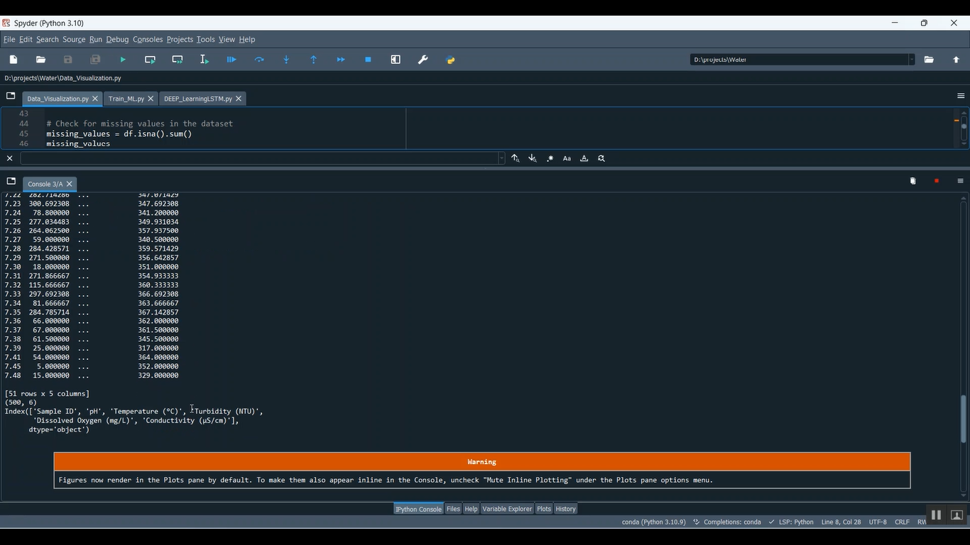

**Fig.8.1.Compilation of Data Visualization**

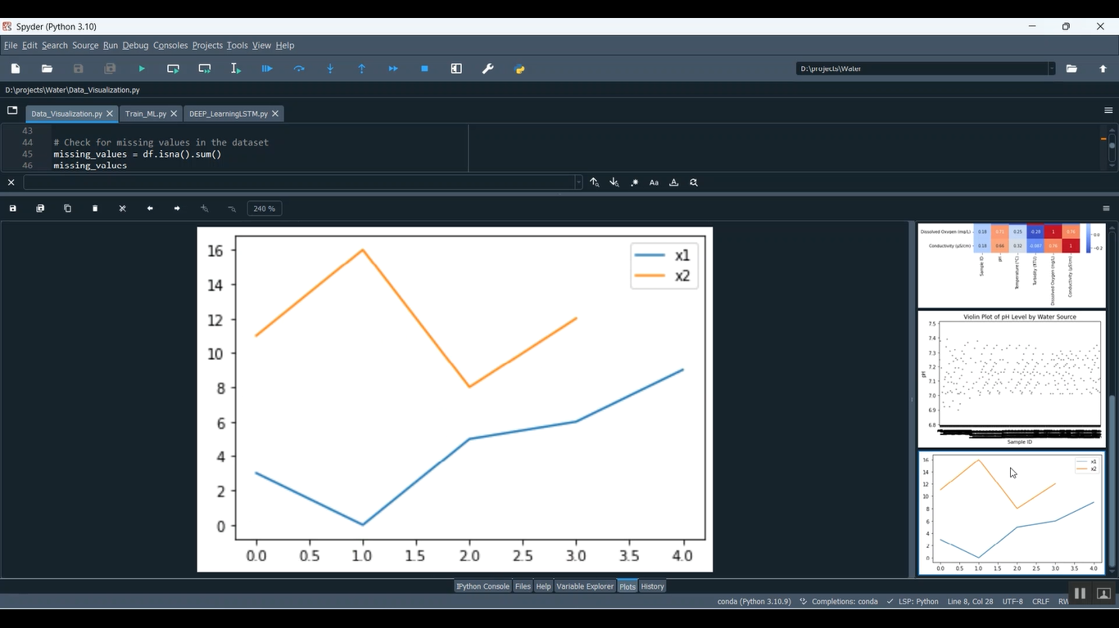

**Fig.8.1.2.Line Graph Diagram**

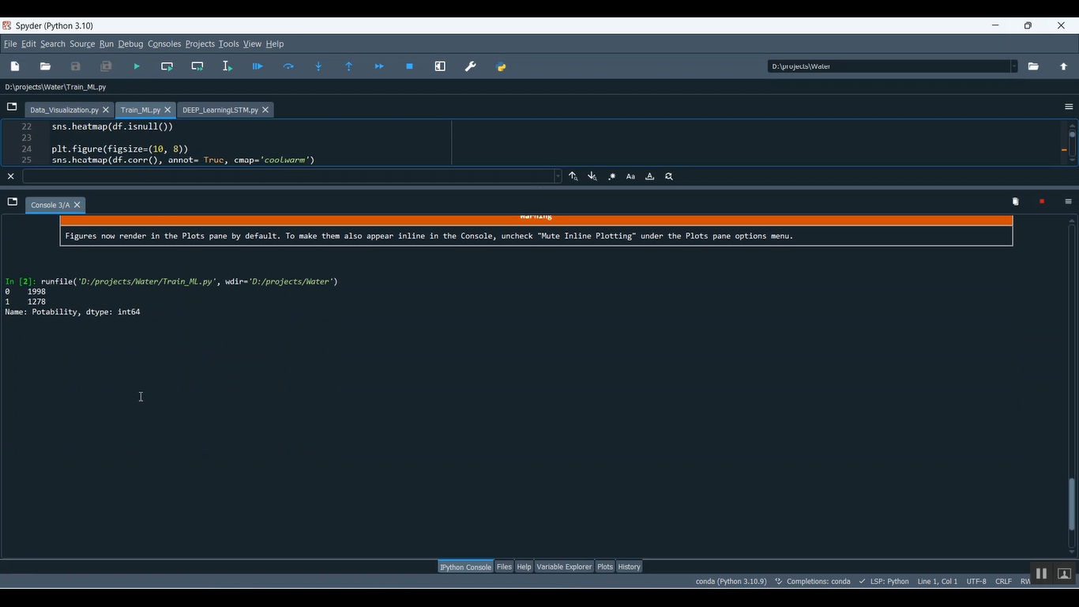

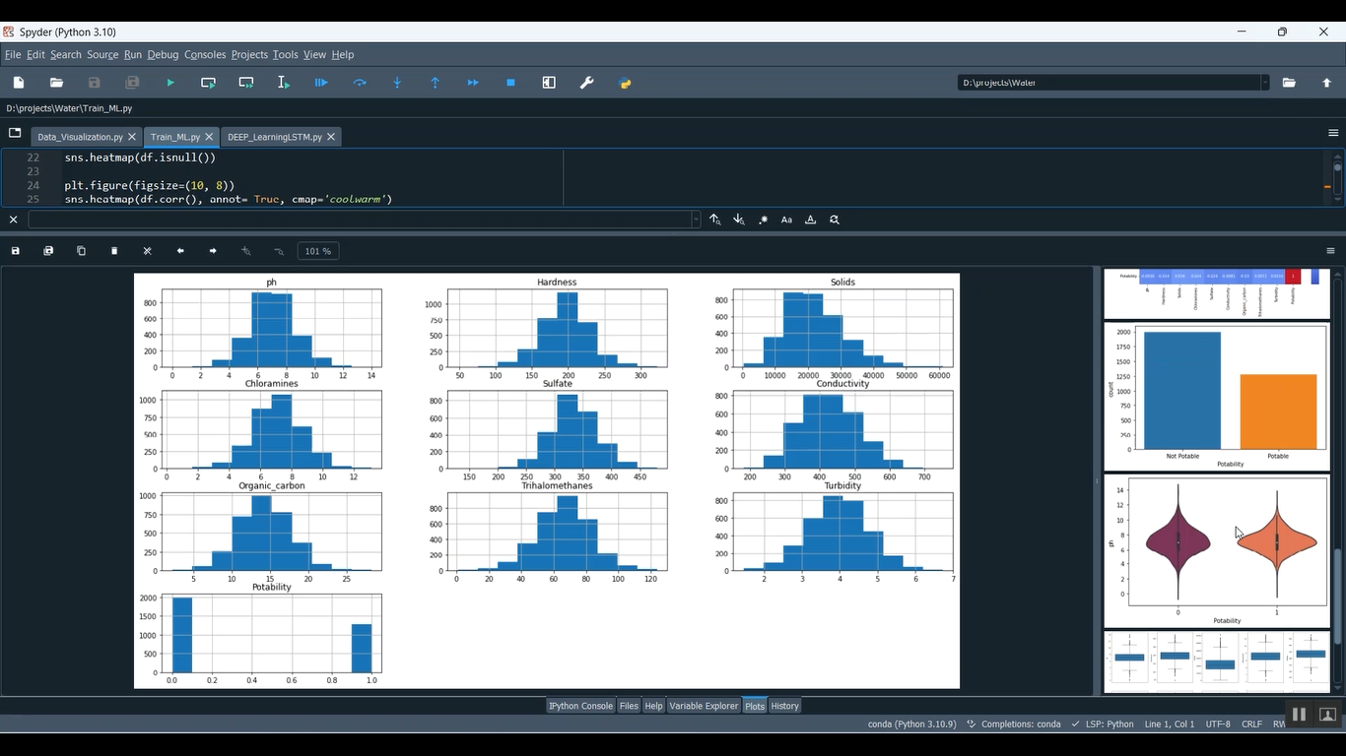

**Fig.8.1.3.Data Flow Diagram**

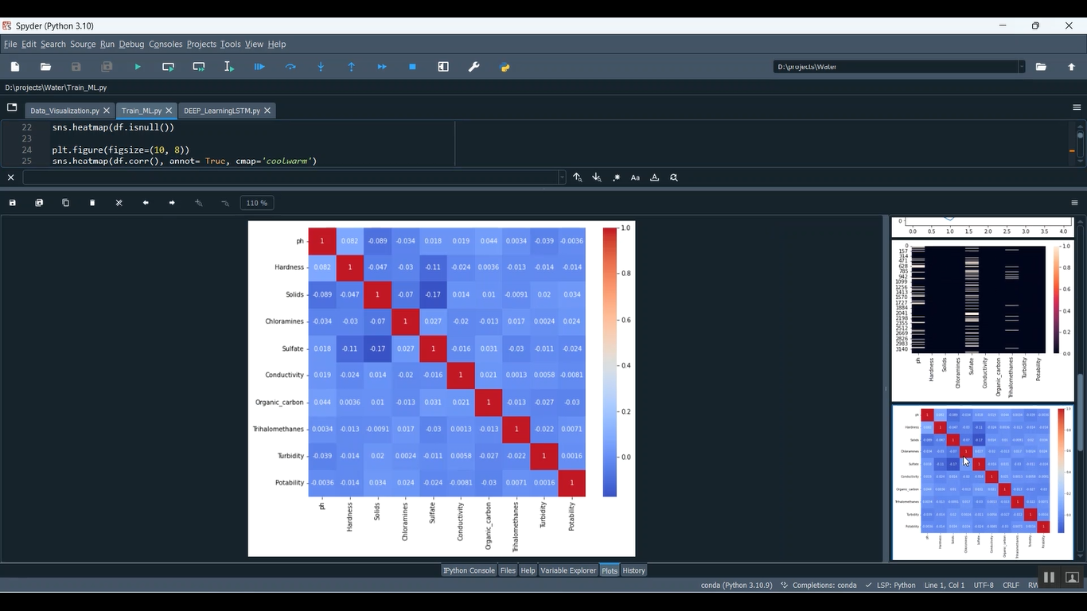

**Fig.8.1.4. Linear Regression Diagram**

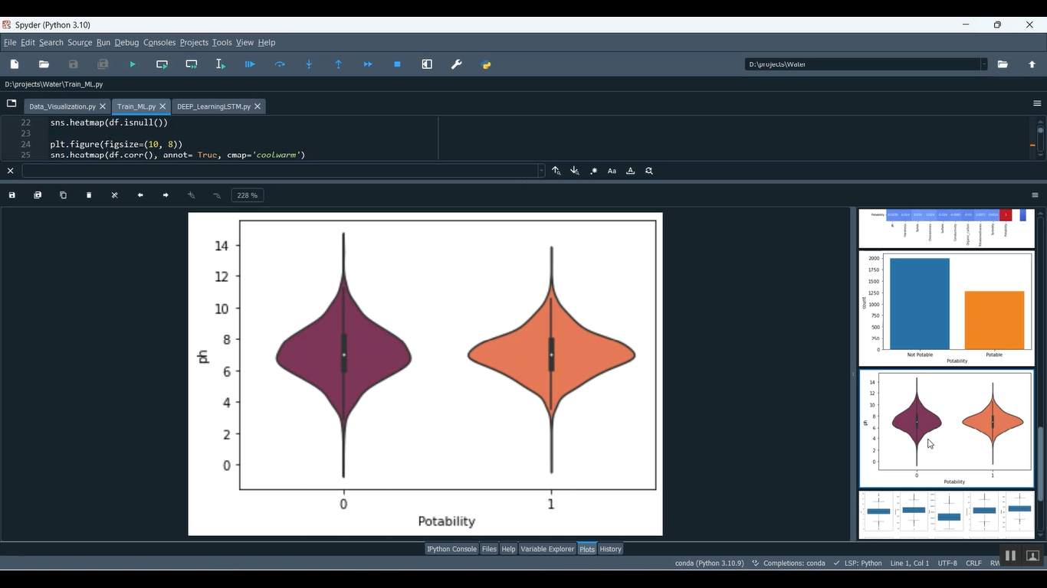

**Fig.8.1.5. Portability Graph Diagram**

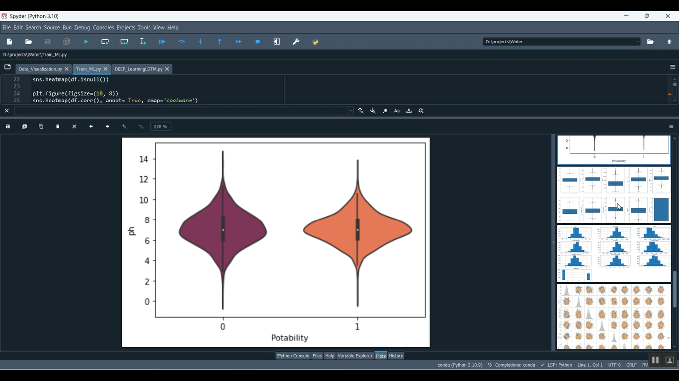

**Fig.8.1.6.DiameterNarrowing Plot Diagram**

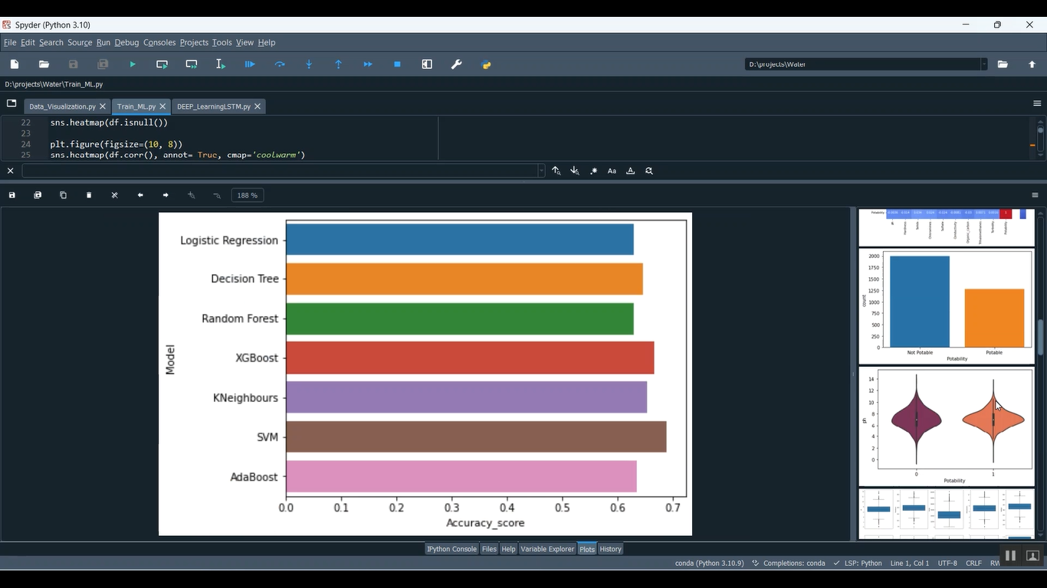

**Fig.8.1.7.Algorithm Diagrams**

.

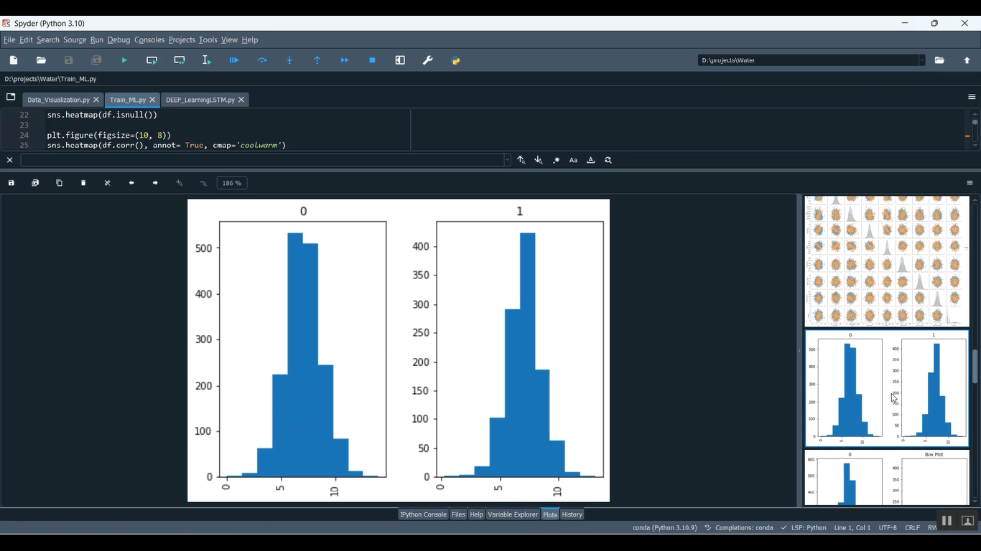

**Fig.8.1.8. Box Plot Diagram**

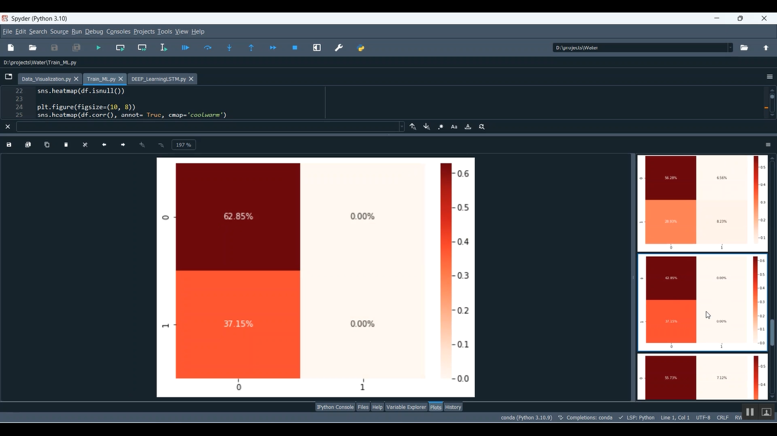

**Fig.8.1.9. Water Level Diagram**

# 

# 

# 

# 

# 

# 

# 

# 

# Fig.8.1.10. Crop yield Prediction

# 

# Fig.8.1.11. PH Value Prediction

# 

# Fig.8.1.12. Water Quality Prediction

# 9. CONCLUSION

The development and implementation of a network for monitoring and assessing water quality for drinking and irrigation purposes represent a pivotal stride towards ensuring the safety of water sources and optimizing agricultural practices. This project's endeavors, encompassing sensor technologies, data analytics, and real-time monitoring systems, underscore the significance of proactive and technologically driven approaches in safeguarding human health and promoting agricultural sustainability.

The amalgamation of advanced sensor technologies has revolutionized our capacity to continuously collect and analyze crucial water quality parameters. Through this network, pH levels, dissolved oxygen content, turbidity, salinity, nutrient concentrations, and contaminants are scrutinized in real-time, providing an unparalleled depth of insight into the health of water sources and their suitability for diverse applications.

The predictive capabilities derived from machine learning algorithms and data analytics have transcended conventional monitoring practices. Early detection of anomalies, forecasting potential risks, and providing timely alerts have empowered stakeholders with actionable insights. Decision-makers, water management authorities, farmers, and local communities now possess the tools necessary to make informed choices, implement interventions, and ensure the resilience of our water resources.

# 10.REFERENCES

**Bibliography**:

Good Teachers are worth more than thousand books, we have them in Our Department

**References Made From:**

1. User Interfaces in C#: Windows Forms and Custom Controls by Matthew MacDonald.
2. Applied Microsoft® .NET Framework Programming (Pro-Developer) by Jeffrey Richter.
3. Practical .Net2 and C#2: Harness the Platform, the Language, and the Framework by Patrick Smacchia.
4. Data Communications and Networking, by Behrouz A Forouzan.
5. Computer Networking: A Top-Down Approach, by James F. Kurose.
6. Operating System Concepts,by Abraham Silberschatz.
7. M. Armbrust, A. Fox, R. Griffith, A. D. Joseph, R. H. Katz, A. Konwinski, G. Lee, D. A. Patterson, A. Rabkin, I. Stoica, and M. Zaharia, “Above the clouds: A berkeley view of cloud computing,” University of California, Berkeley, Tech. Rep. USB-EECS-2009-28, Feb 2009.
8. “The apachecassandra project,” <http://cassandra.apache.org/>.
9. L. Lamport, “The part-time parliament,” ACM Transactionon Computer Systems, vol. 16, pp. 133–169, 1998.
10. N. Bonvin, T. G. Papaioannou, and K. Aberer, “Cost-efficientand differentiated data availability guarantees in data clouds,”in Proc. of the ICDE, Long Beach, CA, USA, 2010.
11. O. Regev and N. Nisan, “The popcorn market. online marketsfor computational resources,” Decision Support Systems,vol. 28, no. 1-2, pp. 177 – 189, 2000.
12. J. Brunelle, P. Hurst, J. Huth, L. Kang, C. Ng, D. C. Parkes, M. Seltzer, J. Shank,and S. Youssef, “Egg: an extensible andeconomics-inspired open grid computing platform,” in Proc.of the GECON, Singapore, May 2006.
13. J. Norris, K. Coleman, A. Fox, and G. Candea, “Oncall: Defeatingspikes with a free-market application cluster,” in Proc.of the International Conference on Autonomic Computing,New York, NY, USA, May 2004.
14. C. Pautasso, T. Heinis, and G. Alonso, “Autonomic resourceprovisioning for software business processes,” Informationand Software Technology, vol. 49, pp. 65–80, 2007.
15. A. Dan, D. Davis, R. Kearney, A. Keller, R. King, D. Kuebler,H. Ludwig, M. Polan, M. Spreitzer, and A. Youssef, “Webservices on demand: Wsla-driven automated management,”IBM Syst. J., vol. 43, no. 1, pp. 136–158, 2004.
16. M. Wang and T. Suda, “The bio-networking architecture: abiologically inspired approach to the design of scalable, adaptive,and survivable/available network applications,” in Proc.of the IEEE Symposium on Applications and the Internet,2001.
17. N. Laranjeiro and M. Vieira, “Towards fault tolerance inweb services compositions,” in Proc. of the workshop onengineering fault tolerant systems, New York, NY, USA,2007.
18. C. Engelmann, S. L. Scott, C. Leangsuksun, and X. He,“Transparent symmetric active/active replication for servicelevelhigh availability,” in Proc. of the CCGrid, 2007.
19. J. Salas, F. Perez-Sorrosal, n.-M. M. Pati and R. Jim´enez-Peris, “Ws-replication: a framework for highly available webservices,” in Proc. of the WWW, New York, NY, USA, 2006.

**Sites Referred:**

<http://www.sourcefordgde.com>

<http://www.networkcomputing.com/>

<http://www.ieee.org>

<http://www.emule-project.net/>